# Python Radio 2: Antennas

[Simon Quellen Field](https://medium.com/@simon.field_37276?source=post_page---byline--f13f2d022c66---------------------------------------)

[Simon Quellen Field](https://medium.com/@simon.field_37276?source=post_page---byline--f13f2d022c66---------------------------------------)

Follow

5 min read

·

Aug 20, 2024

Listen

Share

More

How to get more range

Press enter or click to view image in full size

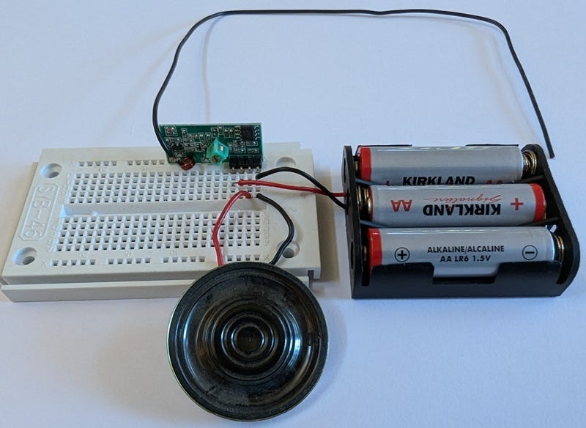

Photo by the author

In the previous article in this series, we built a transmitter and receiver for 433.92 megahertz.

## [Python Radio: Simple Beginnings](https://medium.com/radio-hackers/python-radio-simple-beginnings-9b6498c7c25b?source=post_page-----f13f2d022c66---------------------------------------" \t "_blank)

### **[The simplest digital radio mode](https://medium.com/radio-hackers/python-radio-simple-beginnings-9b6498c7c25b?source=post_page-----f13f2d022c66---------------------------------------" \t "_blank)**

[medium.com](https://medium.com/radio-hackers/python-radio-simple-beginnings-9b6498c7c25b?source=post_page-----f13f2d022c66---------------------------------------" \t "_blank)

It had a simple piece of wire for an antenna. We didn’t worry about how long the wire was or what shape we bent it into.

However, our transmitter only emits 10 milliwatts of radio power, and with low-power transmitters like this, it makes sense to get the most out of it.

Ten milliwatts sounds tiny (and it is). But radio amateurs have awards for communicating 1,000 miles per watt and more:

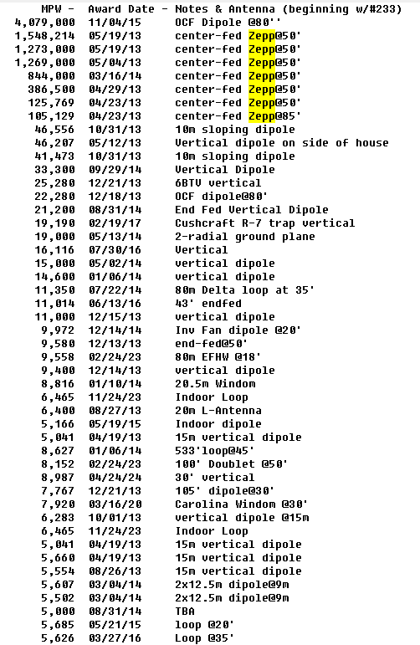

<http://naqcc.info/awards_winners.html>

From our point of view, people who get millions of miles per watt have an advantage. They are using the ionosphere to bend their signals around the earth. But 1,000 miles per watt is a mile per milliwatt, so with perfect conditions and the right antenna, we might see ten miles.

One of the ways to improve our antenna is to make it resonate at the frequency we use. We call this tuning the antenna. Each wave crest meets the echo of the previous one at exactly the right time and they reinforce one another.

To make our antenna resonate, we make the length of the antenna a quarter of a wavelength.

To calculate the wavelength, we ask Google to [divide the speed of light © by 433.92 megahertz](https://www.google.com/search?q=c+%2F+433.92+mhz). It tells us the wavelength is 69.0893386 centimeters. Dividing that by four [gives us 17.27 centimeters](https://www.google.com/search?q=c+%2F+433.92+mhz+%2F+4). We add another millimeter to account for the amount of wire we stick in the hole before soldering it in place.

Now we have antennas, but we can do better. Adding a ground plane is like putting a mirror under the antenna. It doubles the effectiveness. A ground plane can be as simple as a few wires soldered to the ground pin of the transmitter or receiver. We will use three wires. They should be just a little bit longer than a quarter wavelength. We use 12% longer, or about 19 centimeters.

We can optimize further now that we have an antenna and a ground plane. If the ground plane wires are perpendicular to the antenna, the whole antenna system presents 35 ohms of impedance to the transmitter. But our FS1000A is designed to feed a 50-ohm impedance (as are most of the transmitters we will find). If we bend the ground wires down to an angle of 42 degrees from perpendicular, the impedance changes to 50 ohms. If we bend them all the way down, we have now converted our system to a half-wave dipole antenna, which has an impedance of 73 ohms.

If the transmitter’s output impedance is different from the antenna’s input impedance, some of the power gets reflected back into the transmitter, and is not available to the antenna to be radiated into space as radio waves. If the impedances are the same, we get the best power transfer.

Our FS1000A can only put out about 10 milliwatts of power, so we want the transfer to be as good as we can make it. With more powerful transmitters that put out multiple watts, having a big impedance mismatch causes so much power to be reflected back into the transmitter that the output transistor overheats and is destroyed. This can happen if we forget to attach the antenna, or if there is a short circuit to ground. But we don’t have to worry when we are dealing with only 10 milliwatts.

Our transmitter is now raised up on the tripod formed by the ground plane, so we connect it to the ESP8266 using three wires:

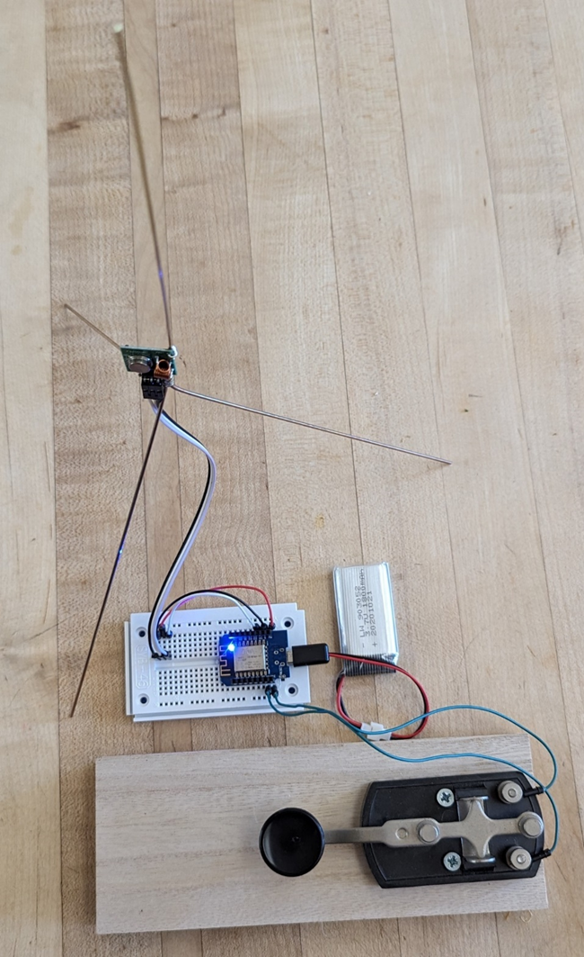

Photo by the author

Likewise with the receiver:

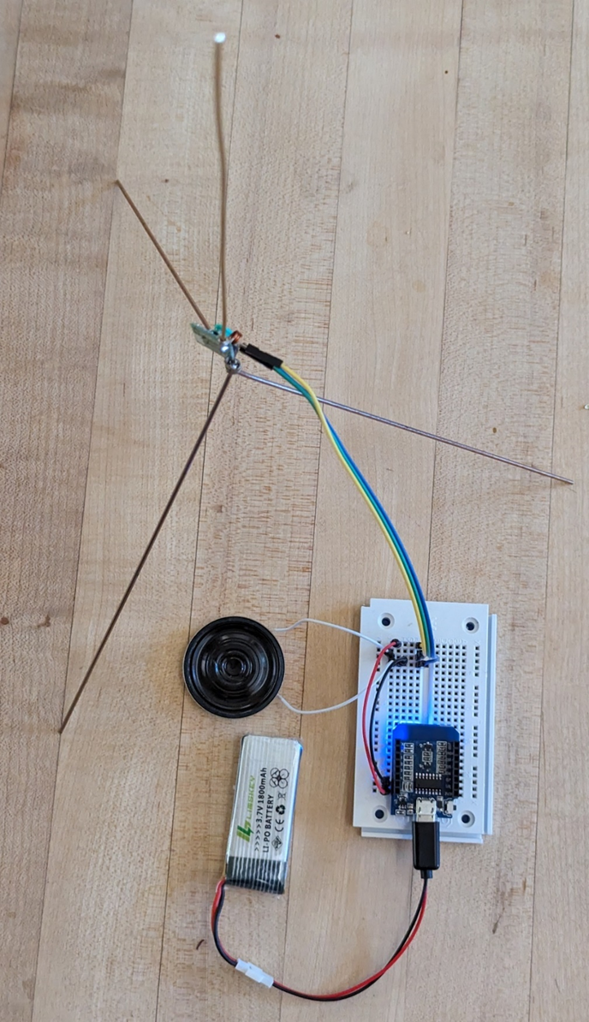

Photo by the author

A closeup of the transmitter shows the connection:

Press enter or click to view image in full size

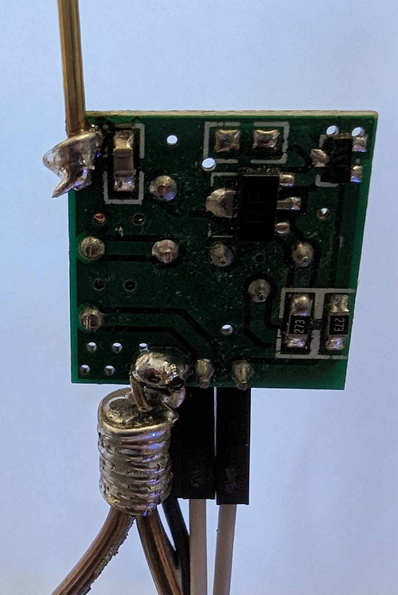

Photo by the author

And the receiver closeup:

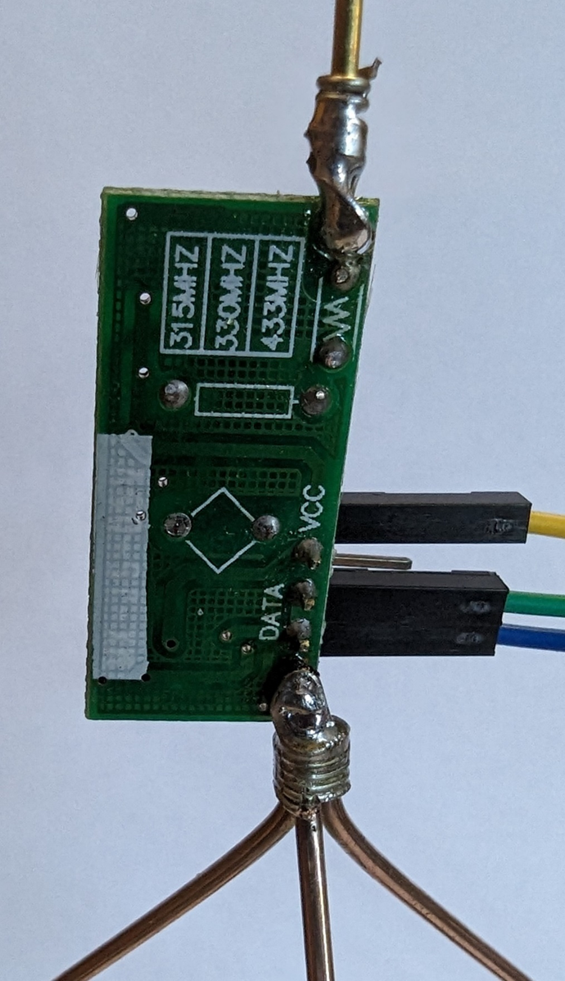

Photo by the author

With the ground plane antennas on the receiver and the transmitter, I was easily able to send and receive Morse code at well over half a kilometer before I ran out of road. These are omnidirectional antennas, so the power is sent out in all directions. If we built directional antennas, such as a Yagi-Uda, we could get much greater distances.

A directional antenna focuses the transmitter power in one direction, much like a lens on a flashlight. Likewise, at the receiver, a directional antenna acts like a telescope, only hearing in one direction, and ignoring interfering noise from other directions. We have improved our signal-to-noise ratio.

There are [online calculators for designing Yagi antennas.](https://www.changpuak.ch/electronics/yagi_uda_antenna_DL6WU.php) A three-element antenna can be made by taping three wires to a piece of cardboard since the whole antenna is only about 9 inches long:

Press enter or click to view image in full size

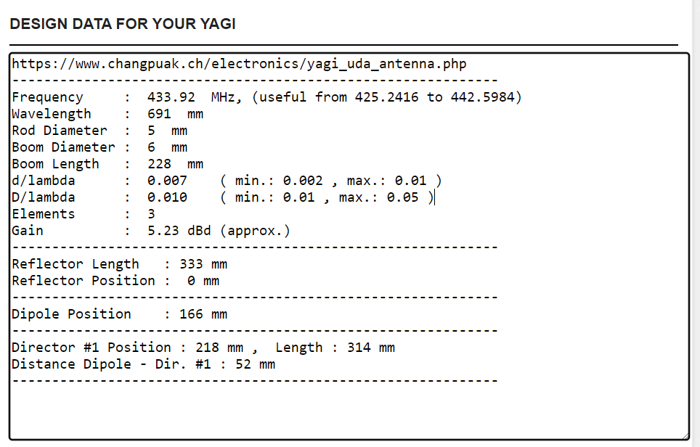

With three elements we get over 5 dBd of gain. With six elements, we get over 9 dBd of gain. You can go nuts and use 20 elements (making the antenna 14 feet long) and get over 15 dBd of gain. That’s like having a 15x telescope at each end of the link.

433.92 megahertz is in the UHF part of the radio spectrum. UHF signals are line-of-sight. They do not bend around the earth. But with the right antennas, you might find that if you can see it, you can signal it. Even with only 10 milliwatts of power. If this is surprising, consider that a 10-milliwatt laser pointer is so bright that you can see it for over 100 miles on a dark night.

[Python](https://medium.com/tag/python?source=post_page-----f13f2d022c66---------------------------------------)

[Micropython](https://medium.com/tag/micropython?source=post_page-----f13f2d022c66---------------------------------------)

[Radio](https://medium.com/tag/radio?source=post_page-----f13f2d022c66---------------------------------------)